**Clubs & Chapters**

At VIT-AP, we believe in fostering an enriching environment where you are enabled to explore your creative selves and take pride in the work you do.

VIT-AP features an array of clubs and chapters that offer you a life beyond academics. Our clubs and chapters provide a recreational space to explore creativity, make new friendships, engage in collaborative work, relax, and socialise. Various club activities eventually lead you to develop a crucial skillset comprising team-work, leadership, and event management. At present, there are more than 70 clubs in the university which include.

TechnicalNon-technicalRegional Club & ChaptersProfessional ClubSocial Outreach Club

[ACM STUDENT CHAPTER](https://vitap.ac.in/clubs-and-chapters/ACM%20STUDENT%20CHAPTER)[NextGen Cloud Club](https://vitap.ac.in/clubs-and-chapters/NextGen%20Cloud%20Club)[GEEKS FOR GEEKS VIT-AP STUDENT CHAPTER](https://vitap.ac.in/clubs-and-chapters/GEEKS%20FOR%20GEEKS%20VIT-AP%20STUDENT%20CHAPTER)[SEDS Aurora](https://vitap.ac.in/clubs-and-chapters/SEDS%20Aurora)[Uddeshya Club](https://vitap.ac.in/clubs-and-chapters/Uddeshya%20Club)[Photon Club](https://vitap.ac.in/clubs-and-chapters/Photon%20Club)[WiOS - Women in Open Source](https://vitap.ac.in/clubs-and-chapters/WiOS%20-%20Women%20in%20Open%20Source)[Machine Learning Club (MLC)](https://vitap.ac.in/clubs-and-chapters/Machine%20Learning%20Club%20(MLC))[Be A Nerd](https://vitap.ac.in/clubs-and-chapters/Be%20A%20Nerd)[Innovators Quest Club](https://vitap.ac.in/clubs-and-chapters/Innovators%20Quest%20Club)[Null Chapter](https://vitap.ac.in/clubs-and-chapters/Null%20Chapter)[Open Source Community: VIT-AP](https://vitap.ac.in/clubs-and-chapters/Open%20Source%20Community:%20VIT-AP)[Computer Society of India](https://vitap.ac.in/clubs-and-chapters/Computer%20Society%20of%20India)[VIT-AP IEEE Student Branch](https://vitap.ac.in/clubs-and-chapters/VIT-AP%20IEEE%20Student%20Branch)

**“ INDIA should lead the world. VIT should lead India ”**

**- Dr. G. Viswanathan, Founder & Chancellor, VIT**

**Celebrations**

In addition to excelling in their academic pursuits, students are involved in a culture of experiencing life through various events on campus. They get to participate in popular weekly student community programs, join the music band or the dance troupe, or activity any other that interests them. Moreover, every year hosts the institute has a mega cultural and technical event that includes popular celebrities and accomplished people from various fields During these events, students are also provided a platform to showcase and develop their skills and talents. In essence, these celebrations play a pivotal role in shaping students into well-rounded individuals equipped with the skills, confidence, and experiences needed to thrive in their academic and professional endeavors.

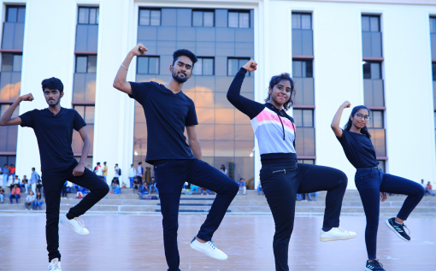

**Vitopia**

Experience Vitopia: VIT-AP's exhilarating International Cultural Fest, where the world converges in a symphony of diversity. From mesmerizing music to captivating dance and awe-inspiring art, immerse yourself in a kaleidoscope of global heritage. Engage in workshops, interactive showcases, and cultural exchanges, fostering unity and understanding. Join us as we celebrate the beauty of differences and the strength of unity at Vitopia—a vibrant tapestry of cultures woven together in harmony. Let's create unforgettable memories and forge lifelong connections, embracing the rich mosaic of humanity.

**[View Gallery](https://vitap.ac.in/gallery)**



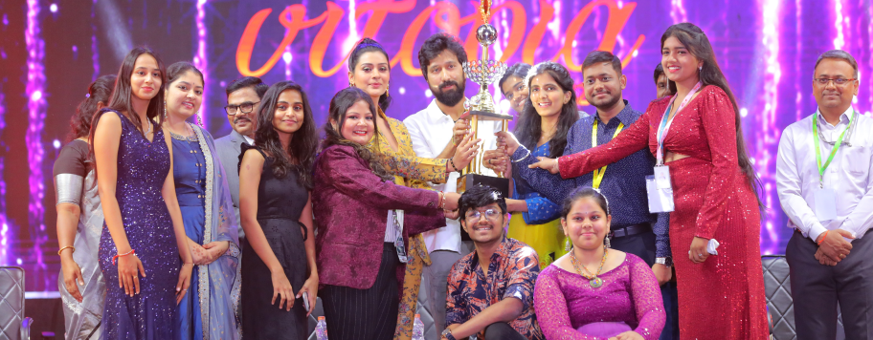





**VTAPP**

VIT-AP proudly presents VTAPP, the pinnacle of innovation and intellect, where brilliance meets boundless possibilities. Delve into the forefront of technology with thrilling competitions, enlightening workshops, and inspiring keynote speeches. Join us as we transcend boundaries, ignite creativity, and pave the way for the future. VTAPP: Where ideas converge, innovation thrives, and endless possibilities unfold, shaping a tomorrow driven by ingenuity and vision.

**[View Gallery](https://vitap.ac.in/gallery)**

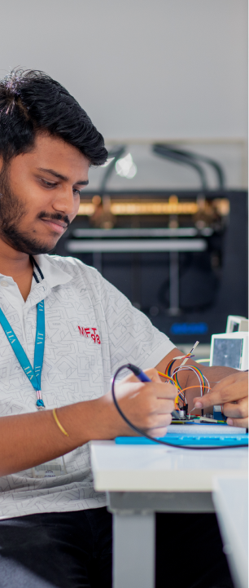

“Competitions“

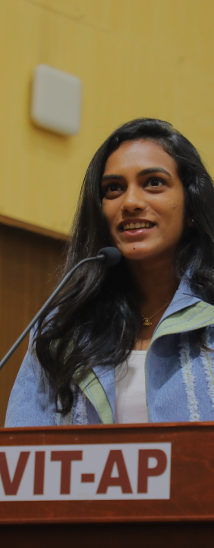

“Speeches“

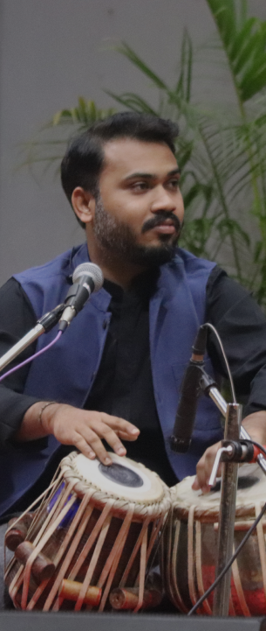

“And More“

**International Women’s Day**

At VIT-AP, our annual celebration of International Women's Day (IWD) is a testament to the remarkable achievements and resilience of women. Through a diverse range of events and initiatives, including panel discussions, film screenings, exhibitions, and awareness campaigns, we highlight the importance of gender equality and women's empowerment. Join us as we commemorate the spirit of IWD and reaffirm our commitment to building a more inclusive and equitable society for all.

**[View Gallery](https://vitap.ac.in/gallery/72)**

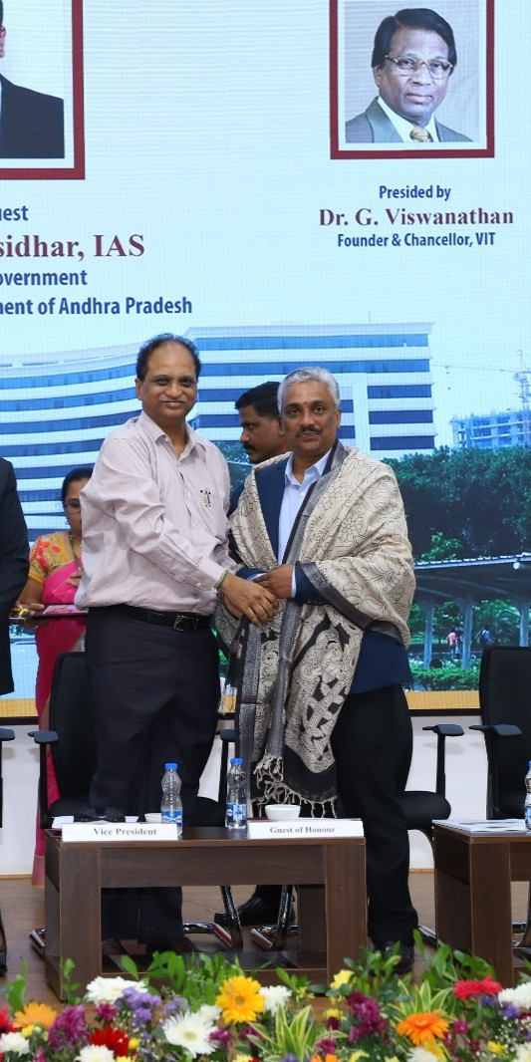

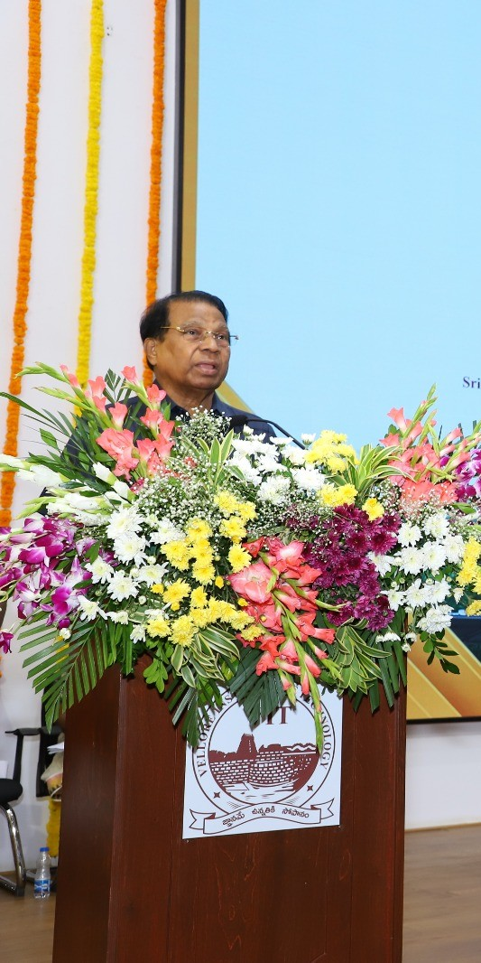

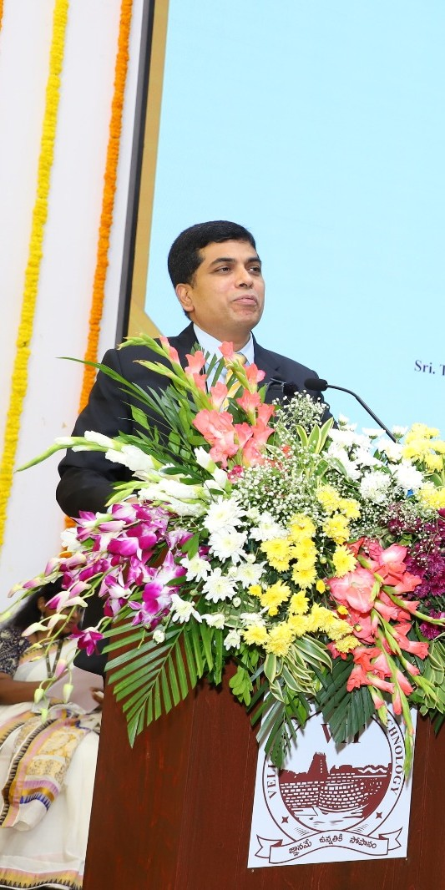

**University Day**

University Day at VIT-AP is a vibrant celebration of our campus community's spirit, unity, and achievements. Through a diverse array of events and activities, including parades, cultural performances, and awards ceremonies, we come together to commemorate our shared journey and successes. Join us as we honor the diversity that enriches our campus, celebrate our collective accomplishments, and reaffirm our commitment to fostering an inclusive and dynamic academic environment. Explore the festivities and programs that highlight the essence of University Day at VIT-AP, where every moment reflects our pride in being a part of this vibrant community.

**[View Gallery](https://vitap.ac.in/gallery/76)**

**Republic Day**

Republic Day at VIT-AP University is a vibrant commemoration of India's democratic heritage and national unity. Marked by traditional flag hoisting ceremonies, inspiring speeches, and cultural performances, this day serves as a testament to our commitment to the ideals of democracy and progress. Join us as we honor the sacrifices of our forefathers, renew our pledge to the nation's advancement, and celebrate the spirit of India. Explore the rich tapestry of events and activities that embody the essence of Republic Day at VIT-AP University, where tradition meets celebration in a tribute to our nation's ethos.

**View Gallery**

**Independence Day**

Independence Day at VIT-AP University is a heartfelt tribute to India's freedom and heritage. Marked by a series of patriotic events, including flag hoisting ceremonies, inspirational speeches, and cultural performances, this day celebrates our nation's journey and aspirations. Join us as we honor the sacrifices of our freedom fighters, celebrate the diversity and unity of our country, and reflect on our collective responsibilities towards nation-building. Explore the activities and programs that encapsulate the spirit of Independence Day at VIT-AP, where pride in our past meets hope for the future.

**[View Gallery](https://vitap.ac.in/gallery/77)**

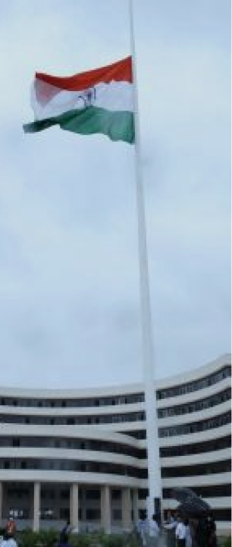

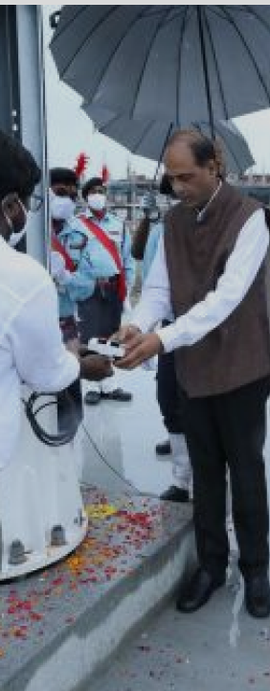

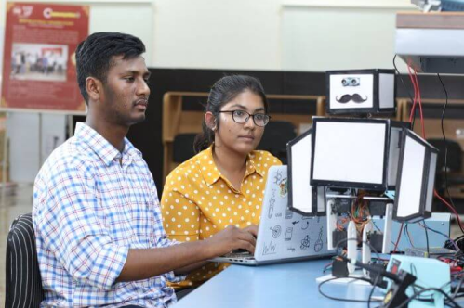

**Science Day**

Science Day at VIT-AP University is a dynamic celebration of scientific inquiry and innovation. Featuring an array of events such as exhibitions, interactive workshops, and enlightening lectures, this day highlights the wonders of science and its impact on our world. Join us as we honor the contributions of scientists, inspire curiosity, and promote a culture of research and discovery. Explore the activities and programs that embody the essence of Science Day at VIT-AP, where passion for knowledge meets the pursuit of excellence in science and technology.

**[View Gallery](https://vitap.ac.in/gallery/71)**

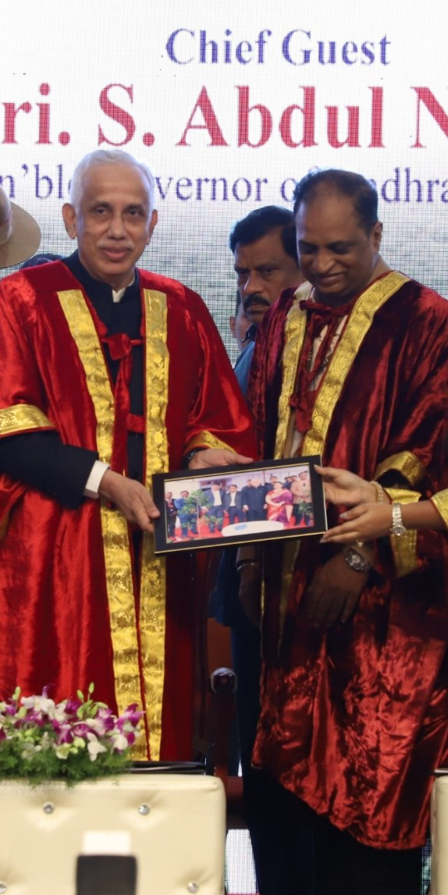

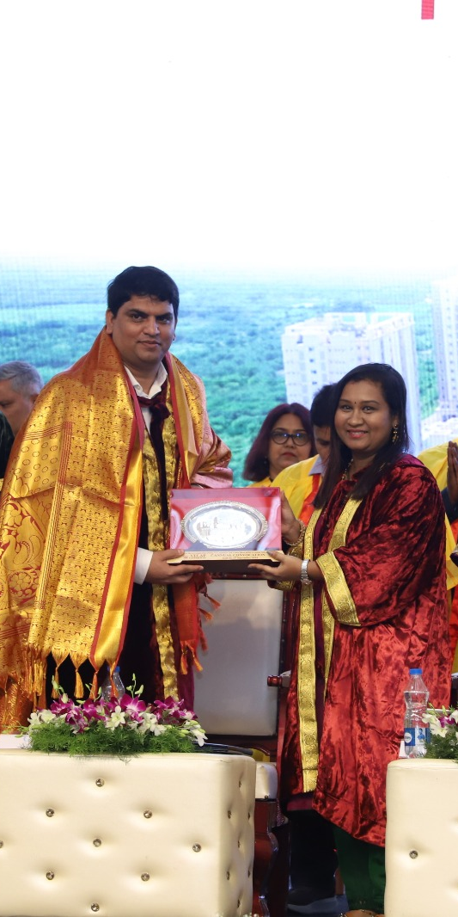

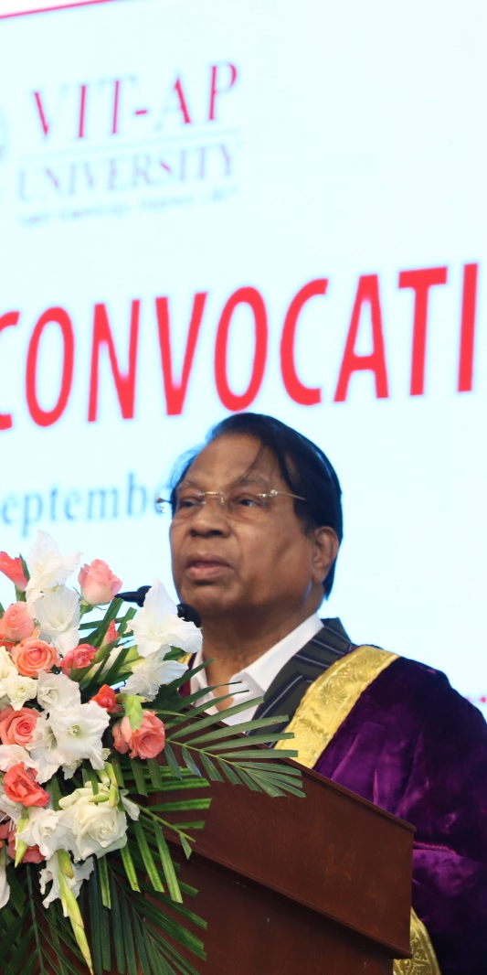

**Convocation Day**

Convocation Day at VIT-AP University is a momentous occasion marking the culmination of academic journeys and the beginning of new chapters in the lives of our graduates. With dignified ceremonies, inspiring speeches, and heartfelt celebrations, we honor the dedication and achievements of our students. Join us as we confer degrees, recognize outstanding accomplishments, and celebrate the academic excellence of our graduates. Explore the traditions and rituals that symbolize the significance of Convocation Day at VIT-AP, where dreams are realized and futures are forged with pride and determination.

**[View Gallery](https://vitap.ac.in/gallery/58)**

**TEDxVITAP**

TEDxVITAP is a dynamic platform at VIT-AP University that showcases innovative ideas and inspiring stories. Organized independently under the official TED license, these events bring together diverse speakers from various fields, including technology, science, arts, and social issues. TEDxVITAP emphasizes student involvement in planning and execution, providing valuable experience in event management and teamwork. The talks inspire and motivate the audience, fostering meaningful discussions and potential collaborations. By promoting innovation and creativity, TEDxVITAP builds a vibrant community of thinkers and doers, aligned with the university's commitment to practical learning and intellectual growth.

**[View Gallery](https://vitap.ac.in/gallery)**

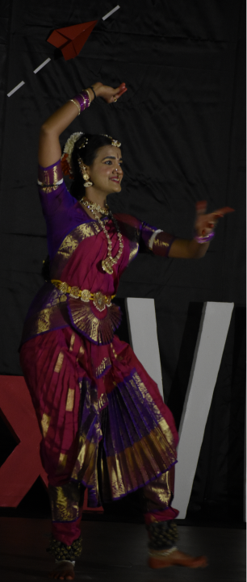

“Technology, “



“Entertainment, “



“and Design“

Gallery

[Republic Day celebrations 2020](https://vitap.ac.in/celebrations/34)

[VITopia sports 2018](https://vitap.ac.in/celebrations/35)

[Womens Day Celebrations 2020](https://vitap.ac.in/celebrations/36)

[Independence Day Celebrations 2020](https://vitap.ac.in/celebrations/37)

[University Day Celebrations - 2022](https://vitap.ac.in/celebrations/38)

[2nd Annual Convocation 2022](https://vitap.ac.in/celebrations/39)

[V-Bond -4th Edition](https://vitap.ac.in/celebrations/40)

[VITopia - 2023](https://vitap.ac.in/celebrations/41)

[77th Independence Day Celebrations](https://vitap.ac.in/celebrations/42)

[3rd Annual Convocation 2023](https://vitap.ac.in/celebrations/43)

[VSL International conference on Comparative law - 2024](https://vitap.ac.in/celebrations/44)

[79th Independence Day Celebrations](https://vitap.ac.in/celebrations/45)

**Cafeteria**

The cafeteria is not just a dining space; it's a hub of culinary delights tailored to meet the diverse needs of our community. From the bustling energy of students grabbing quick bites between classes to the leisurely enjoyment of a full meal, our cafeteria is dedicated to serving up a wide array of delicious and hygienic food options. Beyond the food itself, our cafeteria provides a welcoming and comfortable environment for members to relax, socialize, and enjoy their meals. Whether you prefer to dine in the vibrant atmosphere of the main dining area or seek a quieter space for reflection, our cafeteria offers a range of seating options to suit your preferences. In summary, our cafeteria is more than just a place to eat—it's a culinary destination where good food and community come together.

**Rockplaza**

**The cafeteria is not just a dining space; it's a hub of culinary delights tailored to meet**

**Swagat**

**Maggie Hotspot**

Fuel your break time with tasty Maggie treats

**Foodstreet**

**Food Street is more than just yummy food. It's where you can hang out with friends, chat, and have fun. It's the best place for tasty food and good times with buddies!**

Bits and Bytes

**Canteen**

From quick bites between classes to full meals, the cafeteria serves a wide array of good and hygienic food to all the members.

**Gallery**

**About Sports**

At VIT-AP, we believe that sound mental and good physical health are crucial for holistic development. With a strong emphasis on the recreation of students, VIT-AP students, faculty and staff are provided facilities that keep them active, spirited, involved, and healthy. Several intramural sports events are organised where students compete in cricket, badminton, volleyball, chess etc. Apart from intramural sports, different colleges and universities also participate in our in-house Sports and Cultural fest VITopia,



**Outdoor Facilities**

Basketball Court

Volleyball Court

Tennis Court

Football Field

Cricket Field

Throw Ball

**Basketball Court**

**Basket Ball - 2 Courts**

**Indoor Facilities**

**Badminton Court**

Fitness Indore GYM

Squash Court

T.T, Chess & Carroms Hall

Rock Climbing

Yoga Hall

**Badminton Court**

**Badminton Court - 6 Courts**

**Team Members**

**Dr.N.Ramachandra Rao**

Physical Education Director

+91- 9705273817

ped@vitap.ac.in

**D. Subhasini**

Physical Education Trainer

+91- 9247795593

subhashini.d@vitap.ac.in

**Deekshit Sanga**

Gym Instructor

+91- 8919699412

deekshit.s@vitap.ac.in

**Chandrika Burgula**

Physical Education Trainer

+91- xxxxx xxxxx

chandrika.b@vitap.ac.in

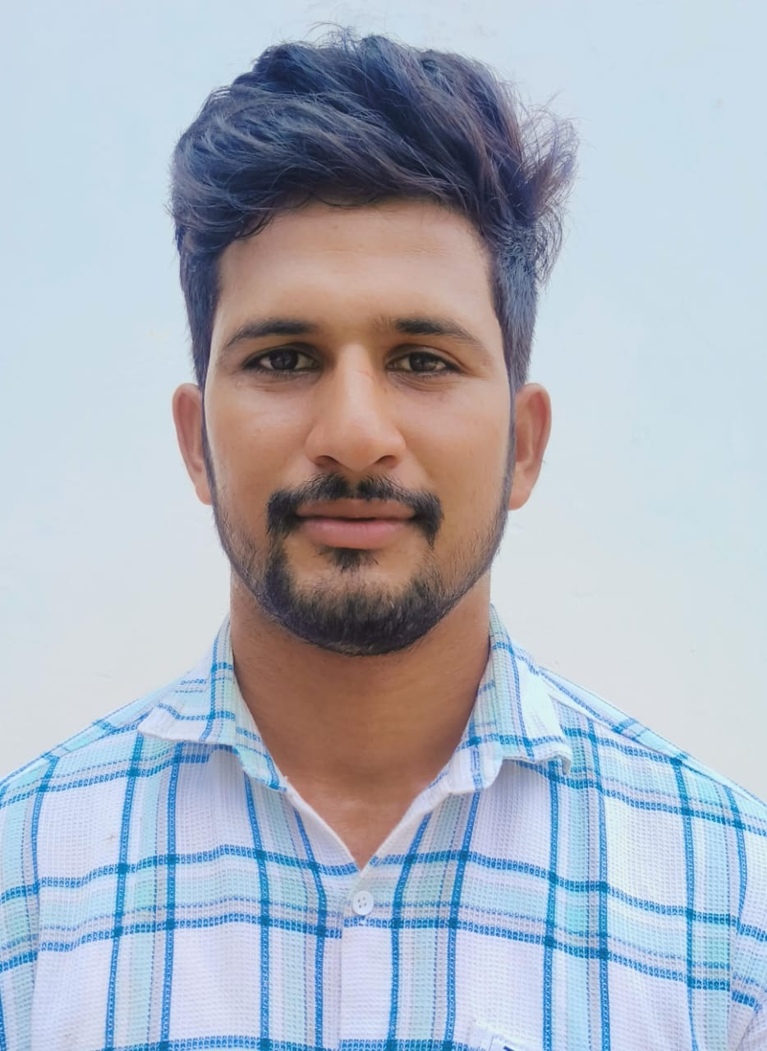

**SHAIK MAHABOOB BASHA**

Physical Education Trainer

+91- 9666363103

mahaboobbasha.Shaik@vitap.ac.in

**Gallery**

**Experience Excellence in Infrastructure**

At VIT-AP, we are dedicated to offering our students an environment that supports both their academic pursuits and their personal enjoyment. Our world-class infrastructure sets the stage for a transformative college experience.

**Secured Environment**

Our hostels are located in the heart of the university campus, ensuring easy access to classes, libraries, and other facilities.

**Academic Blocks**

Well-planned, aesthetically appealing and well - ventilated comprehensive infrastructure is the striking feature of VIT-AP.

Academic Block-1

Area 179090.52 Sq.Ft.

Sarvepalli Radhakrishnan Block

Central Block

Area 4,61,303 Sq.Ft.

Mahatma Gandhi Block

Academic Block-2

Area 183509.99 Sq.Ft.

APJ Abdul Kalam Block

**Academic Block-1**

The Sarvepalli Radhakrishnan Block now has the major administrative offices like the Chancellor's Office, Admissions Office, Finance Office, and other Offices which are responsible for addressing student issues. Apart from these, it also houses the VIT-School of Business (VSB). All the major departments, like the Department of Computer Science, Department of Mechanical Engineering and Department of Electrical Engineering exist here. This block also consists of classrooms and well-designed labs providing the best facilities to students

**Central Block**

The Central Block at VIT AP in Amaravati, Andhra Pradesh, serves as the university's administrative hub and academic center. With its modern design and 10-storey structure, it houses key offices, departments including Computer Science, Electronics, and Humanities, and amenities like a library, auditorium, cafeteria, and health center. Conveniently located at the heart of the campus, it offers easy access to students and staff, supported by Wi-Fi connectivity and transportation links to Amaravati and neighboring areas.

**Academic Block-2**

The APJ Abdul Kalam has School of Sciences and Languages, which comprise of the Departments of Mathematics, Physics, and Languages. This block also has classrooms, labs, space for the auditorium.

**Student Activity Center**

* Well Equipped Indoor Sports And A/C Facilities
* Gymnasium
* Shuttle Court
* BasketBall Court
* Squash Court
* Indoor Sports
* Multi Cuisine Food Court
* Guest House
* Mini Multi Purpose Hall

**World Class Ameneties and Other Facilities**

**Hostels**

**Library**

**Labs**

**Bank & ATM**

**Cafeteria**

**Transport**

**Health Care**

**VIT-AP Hostels**

Our hostels are strategically located within the university campus, providing easy access to academic buildings and facilities. We prioritize the safety and well-being of our students, offering 24/7 security, comfortable living spaces, and a range of amenities.

[Explore More](https://vitap.ac.in/hostels)

**About VIT-AP Hostels**

The VIT-AP hostels are highly secure and well guarded. Only VITians & VIT authorized personnel are allowed inside. We aspire to make the hostel a ‘home away from home. Each hostel room is equipped with a cot, chair, study table and cupboard. Resident wardens are available 24×7. Provision stores are located in the hostel where students can buy essentials such as mattresses, pillows, buckets, mugs, locks, stationeries, books, soaps.

Both AC and Non-AC rooms are available. The type of room is allocated on the first-come first serve basis and availability once the hostel fee is paid in full



**Location**

Our hostels are located in the heart of the university campus, ensuring easy access.



**Amenities**

We provide a wide range of amenities including sports facilities, Wi-Fi and laundry.



**Policies**

Guildlines to maintain a respectful and harmonious living environment.

AMENETIES

Comfortable facilities around hostels

We provide our students the best facilities to study and enjoy their college life

🍽️

Night Canteen

Open until late night

**Variety of delicious food**

📚

Library

24/7 access

**Quiet study environment**

🎮

Indoor Games

Table tennis, foosball, and more

**Recreation and entertainment**

Hostel and Mess Fee Structure

Fall & Winter Semester

NRI/Foreign category

Research Scholars Category

* Hostel admission fee of INR 15000 (non-refundable) is applicable at the time of joining of hostels.
* A caution deposit of INR 15000 (refundable after completion of the course) also to be paid along with the hostel fee.
* All payments are to be made online only
* Hostel fee is inclusive of Room+ Mess+ laundry charges (maximum of 44 washes in 10 Months).
* For Mess and Room upgradation in the fall semester, full differential fee is to be paid and if done in the winter semester 50% of the differential fee has to be paid.
* NO REFUND is applicable for mess (or) room down gradation.
* Refund is based on Hostel refund policy.
* Hostel fee is subject to annual escalation.

**Hostel Team**

Men's Hostel

**Dr. G D V Santosh Kumar**

**Chief Warden**

**Dr. Abdul Raffie Naik**

**Warden – Sarojini Naidu Block (MH-1)**

**Dr.Ramasamy Kavikumar**

**Warden – Rabindranath Tagore Block (MH-2)**

**Dr. Prakash S**

**Warden – Neelam Sanjiva Reddy Block (MH-3)**

**Dr.Mo Faheem**

**Warden – MH-4**

**Dr. Satri Veera Kesalu**

**Warden – MH-5**

**Dr.Sumesh E P**

**Warden – MH6 & MH-7**

**Mr.Ramesh Sahoo**

**Warden – MH6 & MH-7**

**Dr. Sunil Khosla**

**Warden – Discipline**

**Dr.Shobhit Kumar Srivastava**

**Warden-Attendance**

**Dr. Siva G**

**Warden – Food**

**Dr. Muneeswaran M**

**Warden – Events**

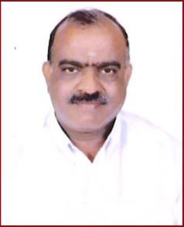

**Mr.Selvaraj**

**Hostel Supervisor**

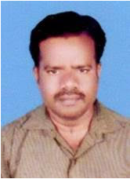

**Mr. Ragupathi Ramasamy**

**Hostel Supervisor**

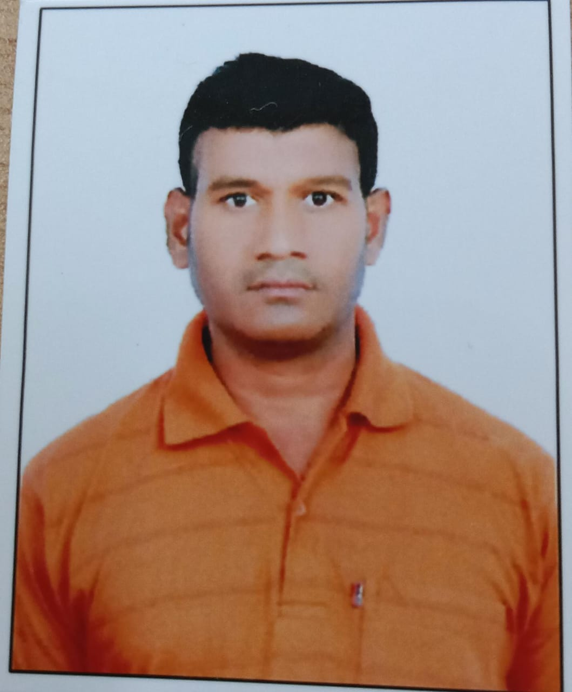

**Mr.K Sreenivasulu**

**Hostel SuperVisor**

Have a look at our hostels

MH1

MH2

MH3

MH4

MH5

MH6

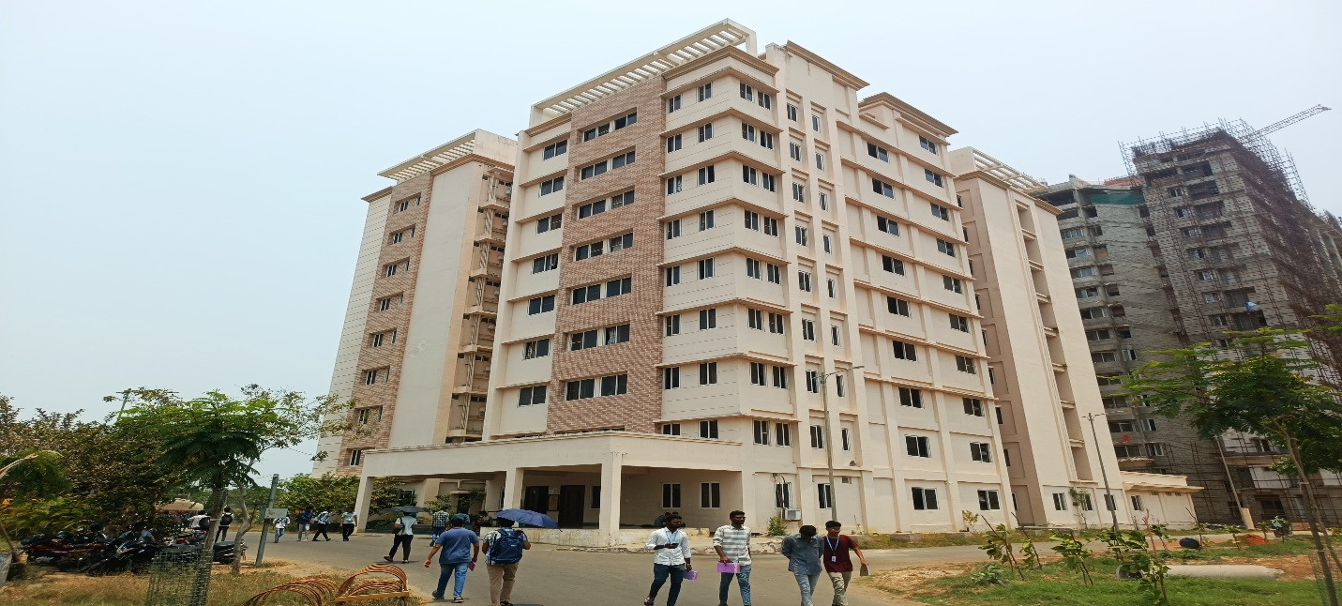

Men's Hostel 1

The VIT-AP hostels are highly secure and well guarded. Only VITians & VIT authorized personnel are allowed inside. We aspire to make the hostel a ‘home away from home. Each hostel room is equipped with a cot, chair, study table and cupboard. Resident wardens are available 24×7. Provision stores are located in the hostel where students can buy essentials such as mattresses, pillows, buckets, mugs, locks, stationeries, books, soaps. Both AC and Non- AC rooms are available.The type of room is allocated on the first - come first serve basis and availability once the hostel fee is paid in full.

Meet our Wardens

**Dr. G D V Santosh Kumar**

Chief Warden

**Dr. Abdul Raffie Naik**

Warden – Sarojini Naidu Block (MH-1)



**Mr.Selvaraj**

Hostel Supervisor

**Dr. Sunil Khosla**

Warden – Discipline

**Dr.Shobhit Kumar Srivastava**

Warden-Attendance

**Dr. Siva G**

Warden – Food

**Dr. Muneeswaran M**

Warden – Events

**08632370501**

**Ladies Hostel**

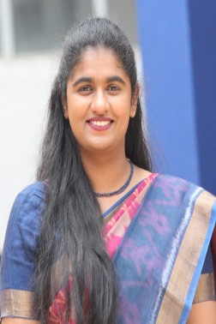

**Dr. Malavika Ganta**

**Chief Warden – Ladies hostel**

**Dr. Renita R**

**Warden – LH-1 & LH-2**

**Ms. Srirupa Poddar**

**Warden – LH-3 & LH-4/ 4A**

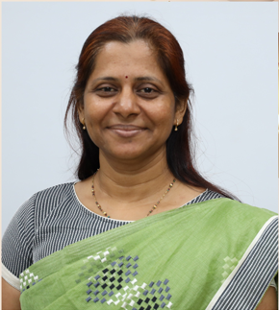

**Ms.Srilakshmi**

**Hostel manager**

**Dr. A Senthamizhselvi**

**Warden – Discipline**

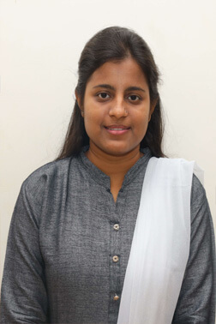

**Dr. Kirtika Sahu**

**Warden-Attendance**

**Dr. Shalini Subramani**

**Warden – Food**



**Dr. Karishma Bisht**

**Warden – Events**

Have a look at our hostels

LH1

LH2

LH3

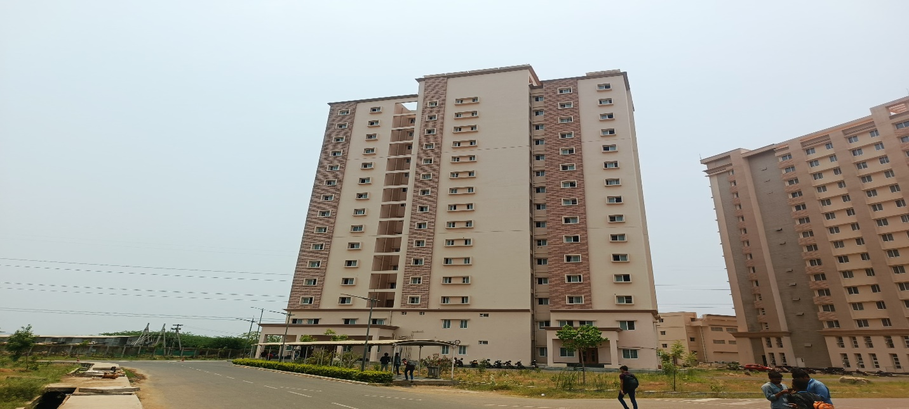

Ladies Hostel 1

The VIT-AP hostels are highly secure and well guarded. Only VITians & VIT authorized personnel are allowed inside. We aspire to make the hostel a ‘home away from home. Each hostel room is equipped with a cot, chair, study table and cupboard. Resident wardens are available 24×7. Provision stores are located in the hostel where students can buy essentials such as mattresses, pillows, buckets, mugs, locks, stationeries, books, soaps. Both AC and Non-AC rooms are available. The type of room is allocated on the first-come first serve basis and availability once the hostel fee is paid in full.

Meet our Wardens



**Dr. Malavika Ganta**

Chief Warden - Ladies hostel

**Dr. Renita R**

Warden – LH-1 & LH-2



**Ms.Srilakshmi**

Hostel manager-1

**Dr. A Senthamizhselvi**

Warden – Discipline



**Dr. Kirtika Sahu**

Warden-Attendance

**Dr. Shalini Subramani**

Warden – Food

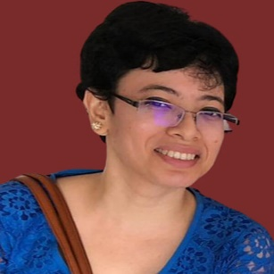

**Dr. Karishma Bisht**

Warden – Events

**08632370600**

[**View**](https://universitywebsitbucket.s3.ap-south-1.amazonaws.com/PDFs/Hostel+Booking-+Withdrawal+and+Refund+Policy.pdf)

Hostel Booking, Withdrawal and Refund Policy

[**View**](https://universitywebsitbucket.s3.ap-south-1.amazonaws.com/Hostels_Page/HOSTELLERS-AFFIDAVIT.pdf)

Hostel Affidavit

[**View**](https://universitywebsitbucket.s3.ap-south-1.amazonaws.com/Hostels_Page/Hostel-Policy-V4.0.pdf)

Rules

[**View**](https://universitywebsitbucket.s3.ap-south-1.amazonaws.com/Hostels_Page/MHCodeofConduct-2019-VIT-AP.pdf)

Code of Condct

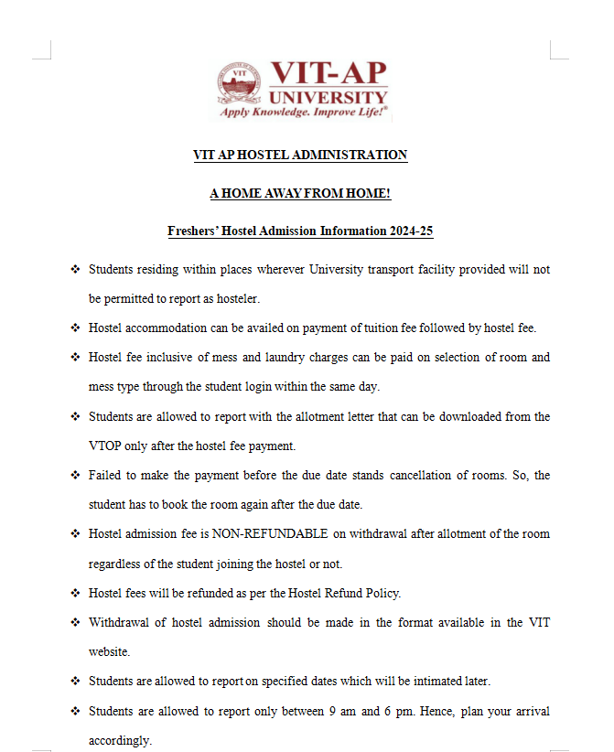

[**View**](https://universitywebsitbucket.s3.ap-south-1.amazonaws.com/Hostels_Page/Fresher+Hostel+Related+Information+.pdf)

Freshers Related Information

**Gallery**

**VIT AP Labs**

There are several laboratories for various programmes offered at VIT-AP. Each laboratory is well-equipped to serve the requirements of the respective programmes. With state-of-the-art facilities, the laboratories are a place for the students to practise, experiment, and innovate.

**Lab Components**

Mechanical EngineeringElectronics EngineeringPhysicsComputer Science

Mechanical Engineering

**Software Licenses:**Solid Work Class Room Pack Edu Edition, Digimat Software

**Advance Manufacturing Lab Equipments:**

3D Printer (DLP)

3D Printer (FDM)

CNC Lathe Machine

CNC Milling Machine

**Fluid Mechanics Lab & Fluid Dynamics Equipments:**

Bernoulli's Apparatus

Centrifugal Pump Test

Fluid Mechanics lab

Francis Turbine

Free and Forced Vortex

Gear Oil Pump

Hydraulic Bench Apparatus

Impact of Jet on Vanes

Loss of Head in pipe Fittings

Metacentric Height

Notch Apparatus

Nozzle Meter Test rig

Open Channel Apparatus

Orific and Mouthpiece combined Apparatus

Pelton Turbine

Pipe Friction Apparatus

Pitot Static Tube Apparatus

Reciprocating Pump

Reynoulds Apparatus

Venturi-Meter and Orifice Meter

Wire Apparatus

**Heat Transfer Lab - Equipments:**

BOMB Calorimeter Apparatus

Cloud and Pour Point Apparatus

Critical Heat Flux

Emissivity Measurement Apparatus

Flash & Fire Point Apparatus

Heat Transfer in Forced Convection

Heat Transfer in Natural Convection

Heat Transfer lab

Heat Transfer through Composite Wall

Heat Transfer through Lagged Pipe

Heat Transfer through Pin-Fin

Plate Type Heat Exchanger

Shell & Tube Heat Exchanger

Stefan Boltzmann Apparatus

Thermal Conductivity of Insulating Powder

Thermal Conductivity of Metal Rod

Unsteady State Heat Transfer Unit

**Manufacturing Processes Lab - Equipments:**

Hot & Cold Rolling Mill

Hot Extrusion Machine

Manufacturing Processes lab

Stir Casting Machine

**Materials Engineering Lab – Equipments:**

Universal Hydraulic Press with Hot Plate

Sigma Mixer

Optical Microscope

Box Furnace

Material Testing Machine (UTM)

Electronic Balance or Weighing Machine

Rockwell Hardness Testing Machine

Injection Moulding Machine

Twin Screw Extruder

Vacuum Oven

Hot Air Oven

Heat Distortions Temperature Apparatus

Hydraulic Press M-30 (Manual)

Ultrasonic Bath Sonicator

Computerized Impact Tester

Material Engineering Lab

Muffle Furnace

Metallurgical Disc Polishing Machine

heat-distortion

Ball Mill

Motorized Notch Cutter

**Mechanical Lab gallery:**

Ultrasonic Welding Machine

TIG & MIG Welding Machine

Bench Grinding Machine

Pillar type Drilling Machine

Hydraulic Press Machine

Hydraulic Power Hacksaw

Surface Grinding Machine

Mechanical Lab

mech2

**Strength of Material Lab - Equipments:**

Fatigue Rotation Bending Testing Machine

Scratch Testing Machine

Rheometer

PIN ON DISK

Digital Micro Vickers Hardness Tester

3D Printer (FDM)

3D Scanning Machine

Impact Testing Machine

Spring Stiffness Tester

Dynamic Mechanical Analysis

Strength Material Lab

Computerised Tensile Testing Machine

**Theory of Machine Lab - Equipments:**

Static & Dynamic Balancing Demonstrator

Whirling of Shafts Demonstrator

Coriolis Component of Acceleration Measuring System

Four Bar Link Mechanism

Theory of Machine Lab

Balancing of Reciprocating Masses Demonstrator

Universal Governor

Comprehensive Vibration Teaching System

Cam & Follower System

Gyroscope

**Thermodynamic Lab - Equipments:**

Two Stage Reciprocating Air Compressor

Single Cylinder 4 Stroke Diesel Engine (VCR)

Heat Pump Test

Computer Based Multi Cylinder (CRDI) Diesel Engine Test with Eddy Current Dynamometer

Air Conditioning Test

Four Stroke Petrol Engine

Vapour Compressor Refrigeration Test

MPFI Petrol Engine for Morse Test

Single Cylinder 4 Stroke Petrol Engine

Two Stroke Petrol Engine

Thermodynamic Lab

**Transport**

VIT-AP provides students with safe and secure buses operated by responsible personnel. Day scholars from Vijayawada, Guntur, and Tenali can conveniently avail themselves of this transportation service. These buses ensure a comfortable commute to and from the campus, fostering a sense of security and reliability for students. By offering this facility, VIT-AP prioritizes the well-being and convenience of its student community, facilitating smooth and hassle-free transportation for those residing in nearby areas.

Mr. M Prudhvi

Transport Executive

Email: transportservice@vitap.ac.in

Phone: 7901091275

**Routes**

Vijayawada

Guntur

Tenali

**Health Care**

The medical needs of the students are taken care by a fully equipped Health Centre on campus along with ambulance facility in Association with Manipal Hospitals, Vijayawada.

**Details**

**Doctors**

Dr. Surya Avinash Ramanapudi

Dr.Lakshmi Lavanya CH

**Nursing Stuff**

Tulasi Kattupalli  
(Nursing Incharge)

Srilatha Gochipatha  
(Staff Nurse)

Anusha Gochipatha  
(Staff Nurse)

**Health Centre**

Outpatient services with 10 bedded fully equipped 24/7

**Emergency Ambulance**

7997965624

**Facilities to Faculty and Staff**

✧

Air-Conditioned cabins and IT facilities are provided to the faculty members.

✧

Free transport facility for all employees.

✧

Medical support: In-house first aid facility is provided.

✧

Faculty and Staff (including their dependents) are covered by health insurance.

✧

Performance Appreciation Pay (PAP): Up to 15 days of gross salary based on the points scored out of 100 (variable pay)

✧

EPF – Employer contribution

✧

Leave encashment options (CL, EL and ML)

✧

Research seed fund support (RGEMS)

✧

Sponsored visit to paper presentations in International Conferences (@ one travel per faculty per year)

✧

Provision for sabbatical leave

✧

Ambulance facility for 24 X 7.

✧

Maternity leave to female employees.

✧

Medical leave.

✧

ATM facility on the Campus.

✧

Canteen facility

✧

Medical leave.

✧

Wifi facility

✧

Other required basic amenities for faculty are available in common areas

**VIT-APCenter forHealing,Awareness andNurturing through**

**Counseling andEmpowerment**

**(V-CHANCE)**

**Counselling Services**

Welcome to V-CHANCE, Center for Healing, Awareness and  
Nurturing through Counseling and Empowerment !

“The good life is a process, not a state of being. It is a direction, not a destination.” – Carl Rogers

At V-CHANCE, we prioritize the mental well-being of our university students, faculty, and staff.

**The Helping Hand**

“We should make it clear that getting help isn’t a sign of weakness – it’s a sign of strength.”- Michelle Obama

The counseling services provided, are open for each student, faculty and staff members of the VIT-AP family. Our mission is to foster a nurturing environment where individuals can explore their thoughts, emotions, and challenges with the guidance of our experienced and highly trained counselors.

**Gains From Seeking Counseling**

The counseling services provided, are open for each student, faculty and staff members of the VIT-AP family. Our mission is to foster a nurturing environment where individuals can explore their thoughts, emotions, and challenges with the guidance of our experienced and highly trained counselors.

**Our Services**

The individual counseling sessions offer a personalized approach to address specific concerns and promote personal growth. Our counselors work collaboratively with clients to develop effective coping strategies and achieve meaningful goals. We offer a range of counseling services to cater to the diverse needs of our university community. Whether you are facing academic stress, personal challenges, relationship issues, or any other emotional difficulties, our team of professional counselors is here to assist you.



**Individual  
Counselling**

Our one-on-one counseling sessions provide a personalized approach, allowing you to freely express yourself and work towards overcoming obstacles.



**Group  
Counselling**

We offer group counseling sessions that provide a supportive environment for sharing experiences and gaining insights from others facing similar challenges.



**Workshops  
& Seminars**

Our center conducts workshops and seminars on various topics related to mental health and personal development, providing valuable tools and strategies for managing stress and enhancing well-being.

**“Confidentiality is a delicate bargain of trust.”- Martin Uzochukwu Ugwu**

Confidentiality in counseling creates a space where the client can explore sensitive subjects in the knowledge that the counselor will not repeat or misuse the information discussed outside of the counseling room. For the counselor, maintaining confidentiality within certain limitations is an ethical responsibility, and it is part of what makes counseling different from other relationships. Your privacy is of utmost importance to us. All counseling sessions are strictly confidential, and information shared during sessions will remain within the counseling center.

**Appointment And Accessibility**

Getting in touch with us is simple. Students, faculty, and staff can reach out for counseling on an appointment basis through email. The counselors are available on an appointment basis from 9am to 6pm during Tuesday to Saturday. We are committed to making our services accessible and inclusive for all members of the university community. At Vellore Institute of Technology Andhra Pradesh (VIT-AP), the counselors are experienced and trained to address a wide range of concerns. Whether you’re facing academic challenges, struggling with personal issues, or simply need someone to talk to, our team is here to lend a listening ear, offer guidance and are ready to assist you in your journey towards self-discovery and empowerment.

**Meet Our Team**

Our team consists of skilled and empathetic counsellors who are dedicated to providing exceptional care and support. Each counsellor is professionally trained and brings a wealth of experience to the counselling process.

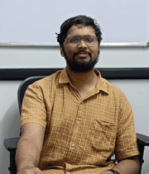

**Anand Mohan K**

Counselor

Cabin No: 404 A 4th Floor

Mahatma Gandhi Block(CB)

student.counselor1@vitap.ac.in

Language:

English, Tamil and Malyalam

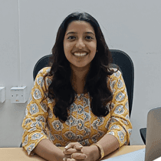

**Ms. Megha K**

Counselor

Cabin No:G18 A Ground Floor

APJ Abdul Kalam Block(ab2)

student.counselor2@vitap.ac.in

Language:

English, Hindi and Malyalam



**Ms Ankita Paul**

Counselor

Cabin No:G18 A Ground Floor

APJ Abdul Kalam Block(ab2)

student.counselor3@vitap.ac.in

Language:

English, Hindi, Assamese and Bengali

**Ms. Saba Khanam**

Counselor

Cabin No: 404,

Mahatma Gandhi Block

student.counselor4@vitap.ac.in

Language:

English and Hindi

**Contact us +91 7901311655, 8333909614, 8333909613, 8333909612, 7901091282**

**Anti Ragging Committee**

What Constitutes Ragging?

**As per the “UGC Regulations on Curbing the Menace of Ragging in Higher Educational Institutions, 2009” the following acts constitutes ragging**

✧

any conduct by any student or students whether by words spoken or written or by an act which has the effect of teasing, treating or handling with rudeness a fresher or any other student

✧

indulging in rowdy or indisciplined activities by any student or students which causes or is likely to cause annoyance, hardship, physical or psychological harm or to raise fear or apprehension thereof in any fresher or any other student

✧

asking any student to do any act which such student will not in the ordinary course do and which has the effect of causing or generating a sense of shame, or torment or embarrassment so as to adversely affect the physique or psyche of such fresher or any other student

✧

any act by a senior student that prevents, disrupts or disturbs the regular academic activity of any other student or a fresher; ✧exploiting the services of a fresher or any other student for completing the academic tasks assigned to an individual or a group of students.

✧

any act of financial extortion or forceful expenditure burden put on a fresher or any other student by students

✧

any act or abuse by spoken words, emails, post, public insults which would also include deriving perverted pleasure, vicarious or sadistic thrill from actively or passively participating in the discomfiture to fresher or any other student

✧

any act that affects the mental health and self-confidence of a fresher or any other student with or without an intent to derive a sadistic pleasure or showing off power, authority or superiority by a student over any fresher or any other student

VIT-AP does not support ragging on campus. The institute strictly prohibits any form of ragging and ensures severe action towards any such reported cases.

**The Anti-Ragging Committee comprises the following:**

Dr. S K Khadeer Pasha

**Convenor**

Dr. N Madhusudhan Rao

**Member**

Dr. Ravindra Dhuli

**Member**

Dr. Umakanta Nanda

**Member**

Dr. S. Srinivas

**Member**

Dr. Benarji Chakka

**Member**

Dr. Arunkumar Sivakumar

**Member**

Dr. Anupriya Elumalai

**Member**

Dr. V. Ravindra Manikanta

**Member**

Dr. Hari Kishan Kondaveeti

**Member**

Dr. John Pradeep

**Member**

Dr. Manas Kumar Pal

**Member**

Dr. P. Kanaka Himabindu

**Member**

Dr. N. K. Rakhi

**Member**

Dr. M. Krishnasamy

**Member**

Dr. Dilip Kumar Monanty

**Member**

Dr. Satyanarayana Badeti

**Member**

Mr. Dayanand Gunti

**Member**

Dr. V. Balasingh

**Member**

Dr. N. Rama Chandra Rao

**Member**

Mr. K Prakash Rao

**Member**

Mr. Abdur Rahman

**Member**

Mr. Prudhvi

**Member**

Mr. V. K. K. S. M Grandhi

**Student Member**

Mr. A. L. S. N. Likhitha

**Student Member**

Any case of ragging or any such misbeaviour by any student can be reported by email or over phone or in person to any one of the members of the Anti-Ragging Committee. All other teaching and non-teaching staff members also may bring the case of any ragging to the knowledge of the Convenor or any Member of the Committee.

Reporting of Cases:

The aforementioned acts may be reported to the committee by any means and additionally through the following email address anti.ragging@vitap.ac.in and hotline number 7901059255.

**Contact Us**

Feel free to contact us at any time we will get back to you as soon as we can

Top of Form

Send

Bottom of Form

**Info**

ant.rag@vitap.ac.in

+91 8333909617

AB-1 G-01

09:00-18:00

Scope of the Committee:

✧ The committee shall hear cases pertaining to the above mentioned acts coming to its notice in whichever form including email or telephone

✧ It shall video record the statements/ testimonies for transparency and future reference

✧ It shall maintain high levels of confidentiality in collection and storing the evidence

✧ The committee shall submit its report along with recommendations to the Office of Registrar within two weeks from the receipt of complaint

✧ For severe cases of ragging, the committee shall file an initial inquiry report and submit it to the Office of Registrar without any delay for further escalation as per Legal guidelines

***The report submitted by the Anti-Ragging Committee shall be forwarded to the Vice-Chancellor for pronouncing the quantum of punishment and corrective measures to avoid recurrence of such acts.***

**Internal Complaints Committee (ICC)**

VIT-AP University has constituted the Internal Complaints Committee (ICC) for the prevention, prohibition and redressal of sexual harassment of employees and students in higher educational institutions – Regulations, 2015, read with Sexual Harassment of Women at Workplace (Prevention, Prohibition and Redressal) Act, 2013, and in partial modification of Office Order No. 449 dated 05.08.2016.

The Internal Complaints Committee is constituted as under to deal with the complaints relating to Sexual harassment at work place.

**The ICC comprises of the following members:**

**Convener & External member**

**Dr. M Sucharitha**

Convener - SENSE

**Ms. Moguluru Iswarya**

External Member - Advocate, High Court of Andhra Pradesh, Associate at Vivek & Associates, Amaravati

**Members**

**Dr. Sudesh Manger**

Member - VISH

**Dr. Sandhya Sadanandan**

Member - SAS

**Dr. Lakshmi Sowjanya Pali**

Member - SAS

**Dr. Dripta De Joarder**

Member - SAS

**Ms. Shahida Banu**

Member - VC Office

**Ms. K Suneetha**

Member - Admissions

**If you think you or anyone around you in campus is harassed or being harassed, what should you do?**

Send an email to:

icc@vitap.ac.in

**Your complaint will be kept CONFIDENTIAL**

**Useful Documents / Notices:**

[[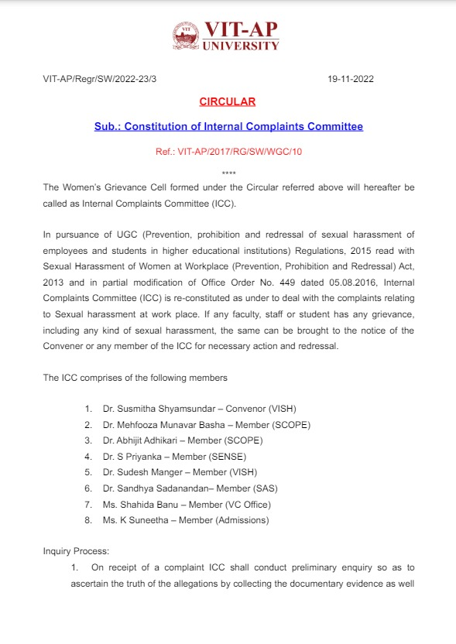](https://universitywebsitbucket.s3.ap-south-1.amazonaws.com/ICC/ICC-circular.pdf)](https://universitywebsitbucket.s3.ap-south-1.amazonaws.com/ICC/ICC-circular.pdf" \t "_blank)

[Tap to View](https://universitywebsitbucket.s3.ap-south-1.amazonaws.com/ICC/ICC-circular.pdf)

Office Order

[[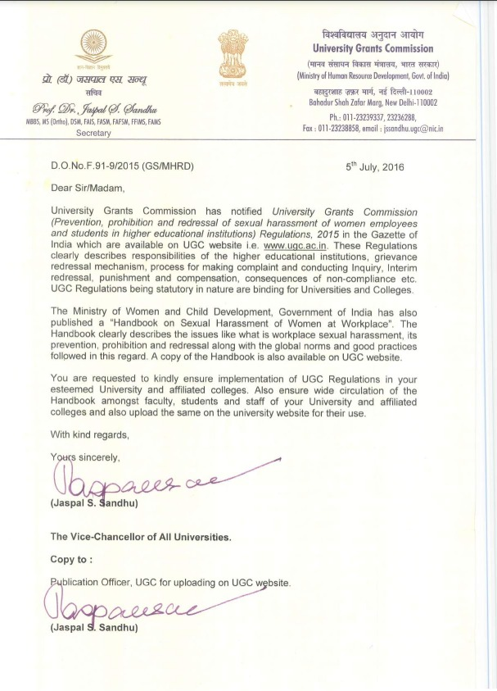](https://universitywebsitbucket.s3.ap-south-1.amazonaws.com/ICC/UGC-2016.pdf)](https://universitywebsitbucket.s3.ap-south-1.amazonaws.com/ICC/UGC-2016.pdf" \t "_blank)

[Tap to View](https://universitywebsitbucket.s3.ap-south-1.amazonaws.com/ICC/UGC-2016.pdf)

UGC / MHRD Notifications

[[](https://universitywebsitbucket.s3.ap-south-1.amazonaws.com/ICC/Handbook-on-Sexual-Harassment-of-Women-at-Workplace.pdf)](https://universitywebsitbucket.s3.ap-south-1.amazonaws.com/ICC/Handbook-on-Sexual-Harassment-of-Women-at-Workplace.pdf" \t "_blank)

[Tap to View](https://universitywebsitbucket.s3.ap-south-1.amazonaws.com/ICC/Handbook-on-Sexual-Harassment-of-Women-at-Workplace.pdf)

Sexual Harrasment Act, 2013

[[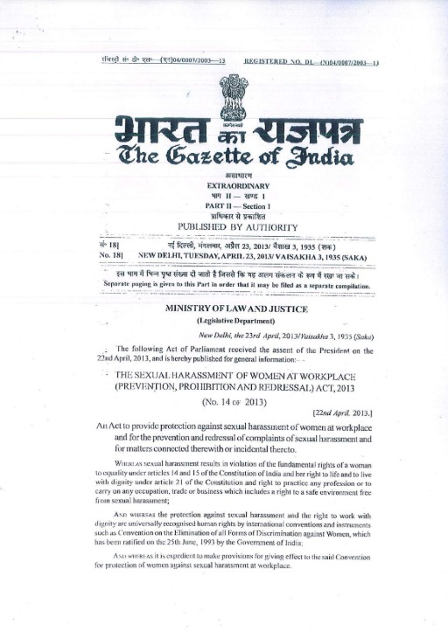](https://universitywebsitbucket.s3.ap-south-1.amazonaws.com/ICC/shc_acts2013.pdf)](https://universitywebsitbucket.s3.ap-south-1.amazonaws.com/ICC/shc_acts2013.pdf" \t "_blank)

[Tap to View](https://universitywebsitbucket.s3.ap-south-1.amazonaws.com/ICC/shc_acts2013.pdf)

Handbook of Sexual Harassment

[[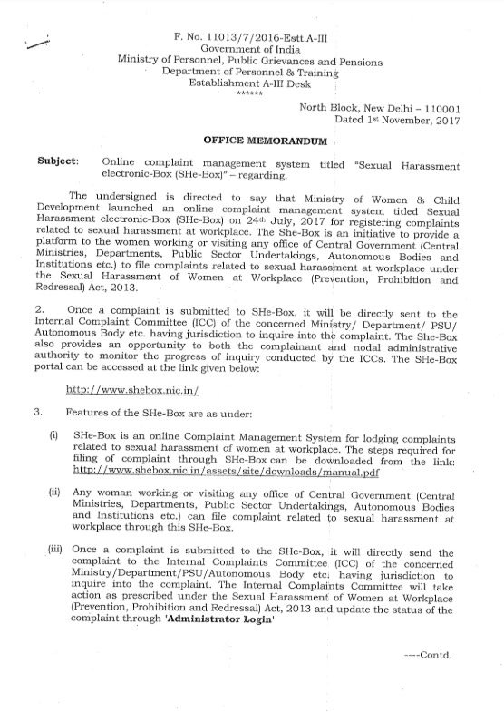](https://universitywebsitbucket.s3.ap-south-1.amazonaws.com/ICC/SHE-Box.pdf)](https://universitywebsitbucket.s3.ap-south-1.amazonaws.com/ICC/SHE-Box.pdf" \t "_blank)

[Tap to View](https://universitywebsitbucket.s3.ap-south-1.amazonaws.com/ICC/SHE-Box.pdf)

SHE-Box

**VIT-AP University Disciplinary Committee**

The UDC comprises of following members:

**Chairman & Co-Chairman**

**Dr. Banerji Chakka**

**Dean, VSL**

**Members**

**Dr. Priyanka Ghosh**

**Faculty, VISH**

**Dr. Aby Abraham**

**Faculty, VISH**

**Dr. P C Lisna**

**Faculty, SAS**

**Dr. Manoj Kumar Gupta**

**Faculty, SMEC**

**Dr. Kanaka Himabindu Pottumuthu**

**Faculty, VISH**

**Dr. Prabhakaran Thandapani**

**Faculty, SAS**

**Dr. Karishma Bisht**

**Faculty, VISH**

**Mr. K Prakash Rao**

**Chief Security Officer**

**Ms. P Haritha**

**Sr. Manager HR**

**Grievance Redressal Committee (GRC)**

As per UGC regulations, the Grievance Redressal Committee and Ombudsman has been constituted for the purpose of redressal of grievances including the cases of caste-based discrimination.

**In accordance to the above the following are nominated as the members of the committee.**

**Name**

**School/Dept**

**Role**

**Dr. Hari Seetha**

**SCOPE**

**Chairman**

**Dr. N. Madhusudhana Rao**

**SAS**

**Member**

**Dr. S K Khadheer Pasha**

**SAS**

**Member**

**Dr. Pankaj Balakrishna Tambe**

**SMEC**

**Member**

**Dr. Reeja S R**

**SCOPE**

**Member**

**Dr. Y. V. Pavan Kumar**

**SENSE**

**Member**

**Dr. M. Kalyan Chakravarthi**

**SENSE**

**Member**

**Dr. Sunnydayal Vanambathina**

**SENSE**

**Member**

**Prof. Pranav Anand Ohja**

**VSL**

**Member**

**Dr. Rakhi N.K**

**VISH**

**Member**

**Dr. Raghavendra**

**VSB**

**Member**

**Mr. K. Sai Babu**

**Library Assistant – Senior**

**Member**

**Ms. L. Sri Lakshmi**

**Ladies Hostel**

**Member**

**Ms. Haritha Parupalli**

**Human Resources**

**Member**

**Mr. Vanaparthi Bulli Siva**

**Student**

**Special Invitee**

**As per the UGC Regulations called as “Redress of Grievances of Students, 2023” defines Grievance as follows:**

✧Making admission contrary to merit determined in accordance with the declared admission policy of the institute;

✧Irregularity in the admission policy is adopted by the institute;

✧Refusing admission in accordance with the declared admission policy of the institute;

✧Non-publication of prospectus, as specified;

✧Publishing any information in the prospectus, which is false or misleading and not based on facts;

✧Withhold or refuse to return any document in the form of certificates of degree, diploma or any other award or other document deposited with it by a person for the purpose of seeding admission in such institution, with a view to induce or compel such a person to pay any fee or fees in respect of any course or program of study which such person does not intend to pursue;

✧Non transparent or unfair evaluation practices;

✧On provision of student amenities as may have been promised or required to be provided by the institution;

✧Making admission contrary to merit determined in accordance with the declared admission policy of the institute;

✧Irregularity in the admission policy is adopted by the institute;

✧Refusing admission in accordance with the declared admission policy of the institute;

✧Non-publication of prospectus, as specified;

✧Publishing any information in the prospectus, which is false or misleading and not based on facts;

✧Withhold or refuse to return any document in the form of certificates of degree, diploma or any other award or other document deposited with it by a person for the purpose of seeding admission in such institution, with a view to induce or compel such a person to pay any fee or fees in respect of any course or program of study which such person does not intend to pursue;

✧Non transparent or unfair evaluation practices;

✧On provision of student amenities as may have been promised or required to be provided by the institution;

Scope and Responsibilities of the Committee:

✧The Grievance Redressal Committee shall fix a date for hearing the complaint, which shall be communicated to the chairman of the committee and the aggrieved person, either in writing or electronically, as may be feasible

✧The quorum for the meeting, including the Chairperson, but excluding the special invitee, shall be three

✧The term of Chairperson and Members, is for a period of two years and that of special invitee is one year,

✧An aggrieved student/ person, may appear either in person, or represented by such person, as may be authorized to present his/ her case

✧Grievance Redressal Committee shall be guided by the principles of natural justice while hearing the grievances,

✧Grievance Redressal Committee shall ensure disposal of every application as speedily as possible, not later than a month and preferably within ten days of receipt of the grievance

✧On the conclusion of proceedings, the Grievance Redressal Committee shall pass such order, with reasons for such order, as may be deemed fit to redress the grievance and provide relief as may be desirable to the affected person/ party at issue

✧The order, so passed shall be provided to the aggrieved student/ person, and the University will comply with the order

Reporting of Cases:

The aforementioned grievances may be reported to the Chairman of the committee by any means and additionally through the following email address grievance.redressal@vitap.ac.in

**Contact Us**

Feel free to contact us at any time we will get back to you as soon as we can

Top of Form

Send

Bottom of Form

**Info**

grievance.redressal@vitap.ac.in

+91 8333909617

AB-1 G-01

09:00-18:00

Role of Ombudsperson:

If in case a student/ person is not convinced by the decision given by the committee; he/ she is at liberty to approach the ombudsman for further trail of hearing. The ombudsman can resolve the issue by following the procedure specified above for the grievance Redressal committee. If in case the ombudsman identifies the complaint to be false/ frivolous appropriate action is suggested against the complainant.

The Ombudsperson for GRC is Dr. Chandini Stephens. She can be contacted on [ombudsman.grc@vitap.ac.in](mailto:ombudsman.grc@vitap.ac.in)

Office Order: [Click Here](https://vitap.ac.in/pdf/GRC_Page/Grievance-Redressal-Committee-GRC.pdf)